**

**CAPSTONE PROJECT REGISTER**

Class: SE0768 Duration time: From 11/05/2015 To 29/08/2015

(*) Profession: <Software Engineer> Specialty: <ES> <IS>

x

(*) Kinds of person make registers: Lecturer Students

x

1. Register information for supervisor (if have)

|  |  |  |  |  |
| --- | --- | --- | --- | --- |
|  | **Full name** | **Phone** | **E-Mail** | **Title** |
| Supervisor 1 | Nguyễn Đức Lợi |  | loind@fpt.edu.vn | Mr. |

2. Register information for students (if have)

|  |  |  |  |  |  |
| --- | --- | --- | --- | --- | --- |
|  | **Full name** | **Student code** | **Phone** | **E-mail** | **Role in Group** |
| Student 1 | Nguyễn Hùng Mạnh | SE60893 | 0905327198 | manhnhse60893  @fpt.edu.vn | Leader |
| Student 2 | Nguyễn Khang Hy | SE61100 | 01697334262 | hynkse61100  @fpt.edu.vn | Member |
| Student 3 | Nguyễn Nhật Linh | SE61040 | 01638193393 | linhnnse61040  @fpt.edu.vn | Member |
| Student 4 | Phạm Nhật Hưng | SE61119 | 01869440902 | hungpnse61119  @fpt.edu.vn | Member |

3. Register content of Capstone Project

(*) 3.1. Capstone Project name:

English: Design and implementation of Products Sorting System based on color

Vietnamese: Thiết kế và thi công hệ thống phân loại sản phẩm theo màu sắc Abbreviation:

- PSSC

- Products Sorting System based on color is one of the useful systems in Industrial and highly applicable in the production line. The system will be designed with three main parts. The first, for the color detecting part, it will use the Light Dependent Resistor (LER) as a sensor to detect the color of the object. Second part, it filter the differentiate products and then sort them to in the same color basket and this part for user to input the number of products. On the conveyor belt, it use infrared sensor to check product is exists or not. If it has one or more products on the conveyor, the infrared sensor will send the signal to the Arduino Controller System. It will open the filter gate to accept only one item go to the right position where the user can get number of output products by differentiate color. The last part, all data will store in a database, the system can manage about quantity of each input or output products by color and monitor on the screen to see the data which is updated real time.

(*) 3.2. Main proposal content (including result and product)

a) Theory and practice (document):

**Block 1:** Inputting products and define color of them.

* Researching about color sensor (like TCS230 or TCS3200…)
* The minimum color that will be determined is three.
* Using some algorithm like K-NN (K-Nearest Neighbor algorithm) or Probability and Statistics or RGB color model, HSL color model... to determine color of products.
* Using other algorithm to support for calculation like Vector Space or Euclidean distance or Manhattan distance, Minkowski distance

**Block 2:** Sorting product by color.

* Researching about some motors (Servo RC motor or Step motor or DC motor)
* Researching how to pulse width modulation for motors.
* Researching about infrared sensor to determine the position of product in the system or on the conveyor system.

**Block 3:** Filter and get products by color and quantity.

* How about the central controller, with mini pc (or laptop)
* How about use real database like SQL Server, MySQL… to store the data.

- Implement the model of Products Sorting and counting System

b) Program:

Hardware: Using Arduino or ARM (Raspberry PI, Beagle Bone or similar products)

Language programming: C, C++ or C#

Tools: Arduino IDE or DEV C++, Visual Studio, Eclipse…

1. Other products:

4. Other comment (propose all relative thing if have)

N/A

|  |  |
| --- | --- |
| **Supervisor (If have)**  *(Sign and full name)* | HCM city, date 14/4/2015 …..  **On behalf of Registers**  *(Sign and full name)* |

*This page is intentionally left blank*

Table of Contents

A. Task Sheet 5

B. Abstracts for Presentations 11

**List of Tables**

Table 1: Task Sheet 10

**List of Figures**

Figure 1: Introduce Capstone Project 11

Figure 2: Introduce Members and Tasks 11

Figure 3: Outline 12

Figure 4: <Overview> Products sorter machine in the world 12

Figure 5: <Overview> Define Problems and Solutions 13

Figure 6: <Overview> Define Scope 13

Figure 7: <How> Overview Block Diagram 14

Figure 8: <How> Block Diagram – Input Marble 14

Figure 9: <How> Block Diagram – Output Marble 15

Figure 10: <How> All hardware we use 15

Figure 11: <How> Arduino Mega 2560 16

Figure 12: <How> TCS3200 Color Sensor 16

Figure 13: <How> Principle of Color Sensor 17

Figure 14: <How> Block Diagram of Color Sensor 17

Figure 15: <How> K – Nearest Neighbor Algorithm 18

Figure 16: <How> Servos 18

Figure 17: <How> Infrared Sensor 19

Figure 18: <How> L298 H Dual Bridge and DC Motor 19

Figure 19: <How> Language Programming 20

Figure 20: <How> Marble Management Interface 20

Figure 21: <How> Report Order Details Interface 21

Figure 22: <How> Mechanical Design 21

Figure 23: <How> Mechanical Detail 22

Figure 24: <Limit and Plan> Testing Report 22

Figure 25: <Limit and Plan> Marbles Limit 23

Figure 26: <Limit and Plan> Improvement Plan 23

Figure 27: Demo Machine 24

Figure 28: Question and Answer 24

1. Task Sheet

|  |  |  |  |  |  |  |  |  |
| --- | --- | --- | --- | --- | --- | --- | --- | --- |
| **No.** | **Product Deliverables** | **Task** | **Nguyễn Hùng Mạnh** | **Nguyễn Khang Hy** | **Nguyễn Nhật Linh** | **Phạm Nhật Hưng** | **Unit** | **Size** |
| 1 | Report1 - Introduction | Project Information | **O** |  |  |  |  |  |
| Introduction |  | **O** |  |  |  |  |
| Current Situation |  |  | **O** |  |  |  |
| Problem Definition |  |  |  | **O** |  |  |
| Proposes Solution | **O** | **O** |  |  |  |  |
| Functional Requirement |  |  | **O** | **O** |  |  |
| Role and Responsibility | **O** |  |  |  |  |  |
| 2 | Report2- Software Project Management Plan | Problem Definition |  | **O** |  |  |  |  |
| Project organization | **O** |  |  |  |  |  |
| Project management plan | **O** |  |  |  |  |  |
| Coding Convention | **O** | **O** |  |  |  |  |
| 3 | Report 3- Software Requirement Specification | User Requirement Specification |  |  | **O** | **O** |  |  |
| **System Requirement Specification** |  |  |  |  |  |  |
| External Interface Requirements |  |  |  |  |  |  |
| User Interface | **O** | **O** | **O** | **O** |  |  |
| Hardware Interface | **O** | **O** | **O** | **O** |  |  |
| Block Diagram | **O** |  |  |  |  |  |
| Block Diagram Details | **O** |  |  |  |  |  |
| Adruino Mega 2560 |  | **O** |  |  |  |  |
| Color Sensor TCS3200 |  | **O** |  |  |  |  |
| Infrared Sensor V1 |  |  | **O** |  |  |  |
| Servo RC | **O** |  | **O** |  |  |  |
| 12V DC Mortor GA37 |  |  |  | **O** |  |  |
| L298 Dual H-Bridge Motor controller |  |  |  | **O** |  |  |
| 12A DC to DC step-sown module |  |  |  | **O** |  |  |
| Communication Protocol | **O** |  |  |  |  |  |
| System Overview Use Case | **O** | **O** | **O** | **O** |  |  |
| **List of Use Case** |  |  |  |  |  |  |
| Config System | **O** |  |  |  |  |  |
| Input Marble |  |  | **O** |  |  |  |
| Output Marble |  |  |  | **O** |  |  |
| View History Order |  | **O** |  |  |  |  |
| **Non-functional Requirement** |  |  |  |  |  |  |
| Usability |  |  | **O** |  |  |  |
| Reliability |  |  | **O** |  |  |  |
| Availability |  |  | **O** |  |  |  |
| Sercurity |  | **O** |  |  |  |  |
| Maintainability |  |  |  | **O** |  |  |
| Portability |  | **O** |  |  |  |  |
| Performance |  |  |  | **O** |  |  |
| Conceptual Diagram | **O** | **O** |  |  |  |  |
| 4 | Report 4- Software Design Description | **System Architectural Design** |  |  |  |  |  |  |
| Hardware Program Architecture description | **O** | **O** |  |  |  |  |
| Desktop Application Architecture description | **O** |  | **O** | **O** |  |  |
| **Class specification (states, behaviors)** |  |  |  |  |  |  |
| Marble | **O** |  |  |  |  |  |
| Orders | **O** |  |  |  |  |  |
| OrdersDetails | **O** |  |  |  |  |  |
| PortSettings | **O** |  |  |  |  |  |
| Repositories | **O** |  |  |  |  |  |
| Kselection |  | **O** |  |  |  |  |
| ColoranalysisTable |  | **O** |  |  |  |  |
| ColorDetection |  | **O** |  |  |  |  |
| ColoranalysisItem |  | **O** |  |  |  |  |
| Globals |  | **O** |  |  |  |  |
| Component Diagram | **O** |  |  |  |  |  |
| **Detailed Description of Components** |  |  |  |  |  |  |
| **Class Diagram** |  |  |  |  |  |  |
| Desktop Application Class Diagram |  |  | **O** | **O** |  |  |
| K-Nearest Neighbor Class Diagram |  | **O** |  |  |  |  |
| Class diagram Explanation | **O** |  |  |  |  |  |
| **Flowchart Diagram** |  |  |  |  |  |  |
| Input Marble Flowchart Diagram |  |  | **O** |  |  |  |
| Output Marble Flowchart Diagram |  |  |  | **O** |  |  |
| View Order Details Flowchart Diagram |  | **O** |  |  |  |  |
| Configure Ports Flowchart Diagram | **O** |  |  |  |  |  |
| **Sequence Diagram** |  |  |  |  |  |  |
| Input Marble Sequence Diagram |  |  | **O** |  |  |  |
| Output Marble Sequence Diagram |  |  |  | **O** |  |  |
| View Order Details Sequence Diagram |  | **O** |  |  |  |  |
| Configure Ports Sequence Diagram | **O** |  |  |  |  |  |
| **Activity Diagram** |  |  |  |  |  |  |
| Input Marble Activity Diagram |  |  | **O** |  |  |  |
| Input Marble Details Activity Diagram | **O** |  | **O** |  |  |  |
| Output Marble Activity Diagram |  |  |  | **O** |  |  |
| Output Marble Details Activity Diagram | **O** |  |  | **O** |  |  |
| View Order Details Activity Diagram |  | **O** |  |  |  |  |
| Configure Ports Activity Diagram | **O** |  |  |  |  |  |
| **User Interface Design** |  |  |  |  |  |  |
| Repository Interface Design |  |  | **O** | **O** |  |  |
| Report Interface Design |  | **O** |  |  |  |  |
| Configuration Interface Design | **O** |  |  |  |  |  |
| Database Design |  | **O** |  |  |  |  |
| **Algorithms** |  |  |  |  |  |  |
| K-Nearest Neighbor Algorithms |  | **O** |  |  |  |  |
| 5 | Report 5 - Software Implementation and Test Document | **Coding** |  |  |  |  |  |  |
| **Hardware Program** |  |  |  |  |  |  |
| Algorithms |  | **O** |  |  |  |  |
| Arduino Program | **O** |  |  |  |  |  |
| Servo |  |  | **O** |  |  |  |
| Infrared Sensor |  |  | **O** |  |  |  |
| TCS3200 Color Sensor |  | **O** |  |  |  |  |
| Conveyor belt |  |  |  | **O** |  |  |
| **Desktop Application** |  |  |  |  |  |  |
| Core Program | **O** |  |  |  |  |  |
| Manage Repository |  |  | **O** | **O** |  |  |
| Report |  | **O** |  |  |  |  |
| Configuration Port | **O** |  |  |  |  |  |
| **Introduction** |  |  |  |  |  |  |
| Overview |  |  |  | **O** |  |  |
| Test Approach |  |  |  | **O** |  |  |
| **DB Relationship Diagram** |  |  |  |  |  |  |
| Physical Diagram |  | **O** |  |  |  |  |
| Data Dictionary |  |  | **O** |  |  |  |
| **Performance Measures** |  | **O** |  |  |  |  |
| **Test Plan** |  |  |  |  |  |  |
| Features to be tested | **O** |  |  |  |  |  |
| Features not to be tested | **O** |  |  |  |  |  |
| **Write Test case** |  |  |  |  |  |  |
| TCS3200 Sensor Color | **O** |  |  |  |  |  |
| Servo RC | **O** |  |  |  |  |  |
| Infrared Sensor | **O** |  |  |  |  |  |
| Input Marble |  | **O** | **O** |  |  |  |
| Output Marble |  |  | **O** | **O** |  |  |
| Export order details |  |  |  | **O** |  |  |
| **System Testing Test Case** |  |  |  |  |  |  |
| **Component Testing** |  |  |  |  |  |  |
| TCS3200 Sensor Color | **O** |  |  |  |  |  |
| Servo RC | **O** |  |  |  |  |  |
| Infrared Sensor | **O** |  |  |  |  |  |
| **Integration Testing** |  |  |  |  |  |  |
| Input Marble |  | **O** | **O** |  |  |  |
| Output Marble |  |  | **O** | **O** |  |  |
| Export order details |  |  |  | **O** |  |  |
| 6 | Report 6 - Software User's Manual | **Installation Guide** |  |  |  |  |  |  |
| Setting Up Environment |  |  | **O** | **O** |  |  |
| Deployment |  |  | **O** | **O** |  |  |
| **User’s Guide** |  |  |  |  |  |  |
| Configure Ports | **O** |  |  |  |  |  |
| Input Marble |  |  | **O** |  |  |  |
| Output Marble |  |  |  | **O** |  |  |
| View customer Marble |  | **O** |  |  |  |  |
| **Appendix** | **O** | **O** | **O** | **O** |  |  |

Table 1: Task Sheet

1. Abstracts for Presentations

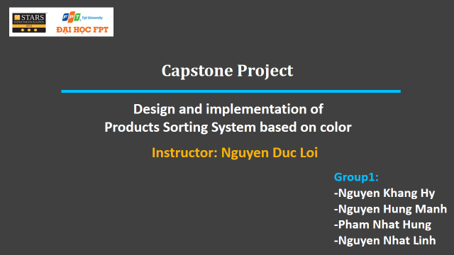

Figure 1: Introduce Capstone Project

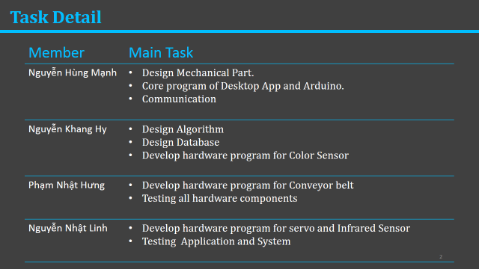

Figure 2: Introduce Members and Tasks

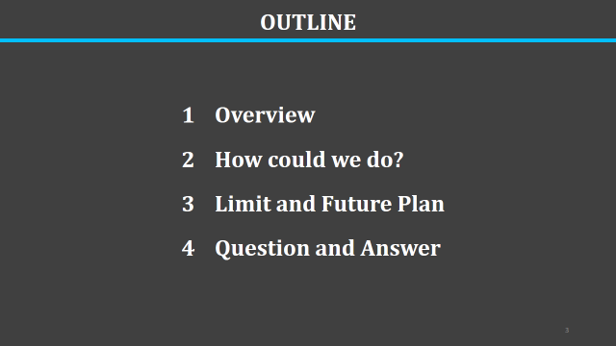

Figure 3: Outline

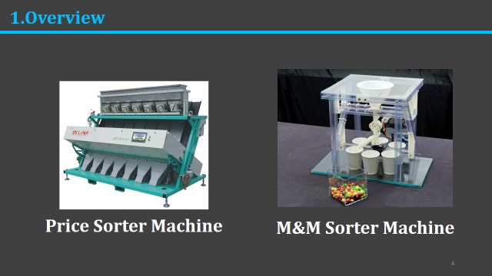

Figure 4: <Overview> Products sorter machine in the world

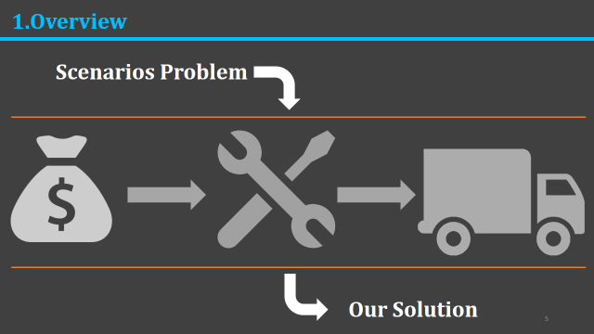

Figure 5: <Overview> Define Problems and Solutions

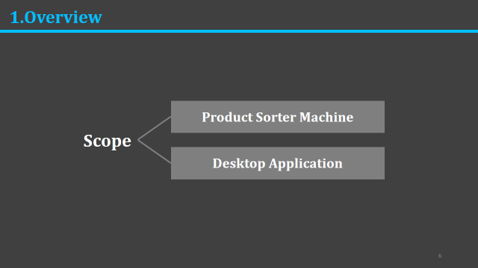

Figure 6: <Overview> Define Scope

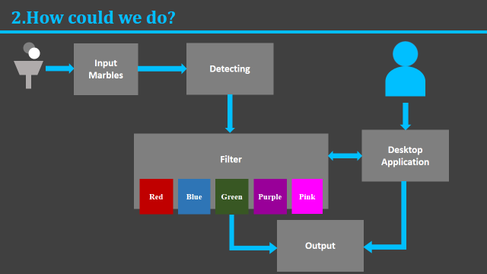

Figure 7: <How> Overview Block Diagram

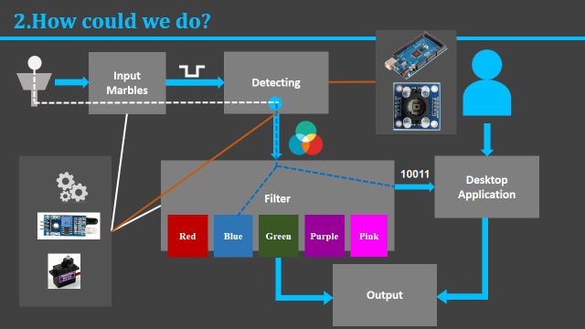

Figure 8: <How> Block Diagram – Input Marble

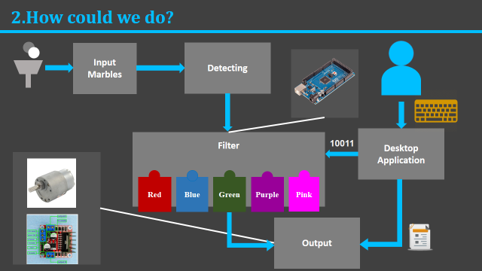

Figure 9: <How> Block Diagram – Output Marble

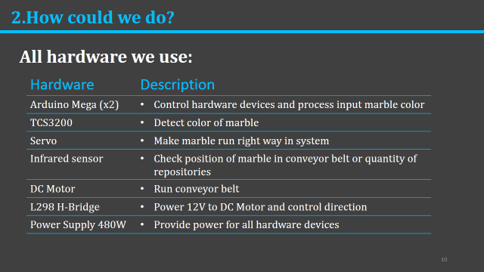

Figure 10: <How> All hardware we use

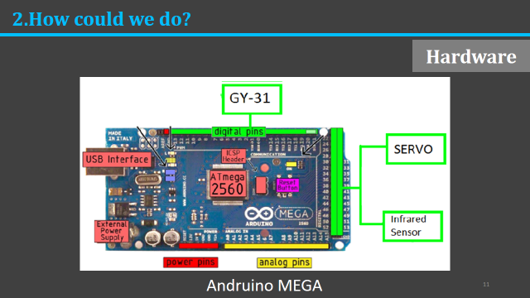

Figure 11: <How> Arduino Mega 2560

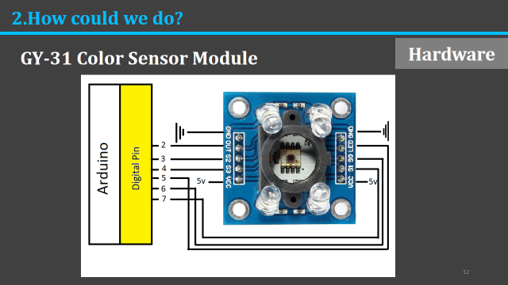

Figure 12: <How> TCS3200 Color Sensor

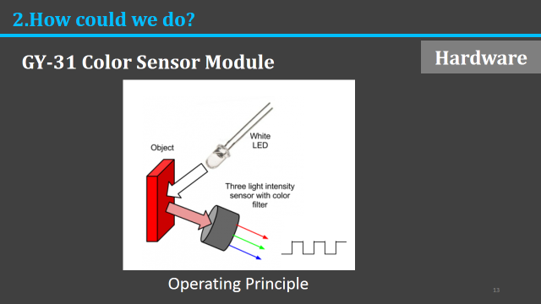

Figure 13: <How> Principle of Color Sensor

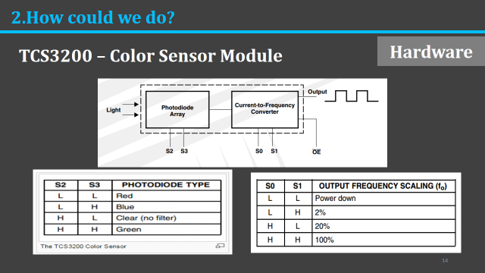

Figure 14: <How> Block Diagram of Color Sensor

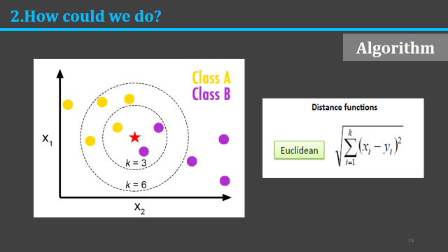

Figure 15: <How> K – Nearest Neighbor Algorithm

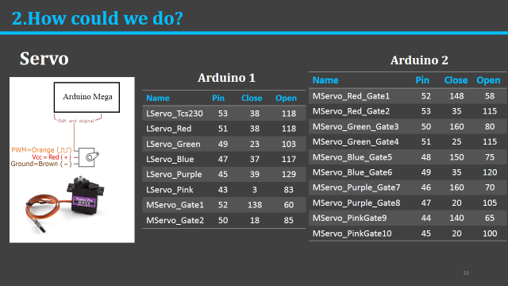

Figure 16: <How> Servos

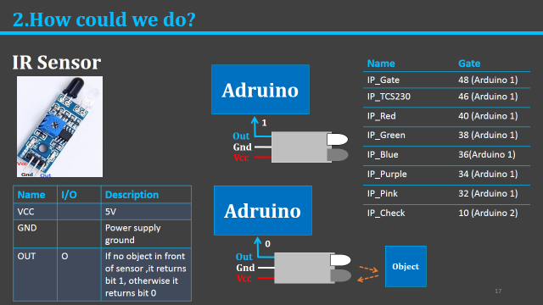

Figure 17: <How> Infrared Sensor

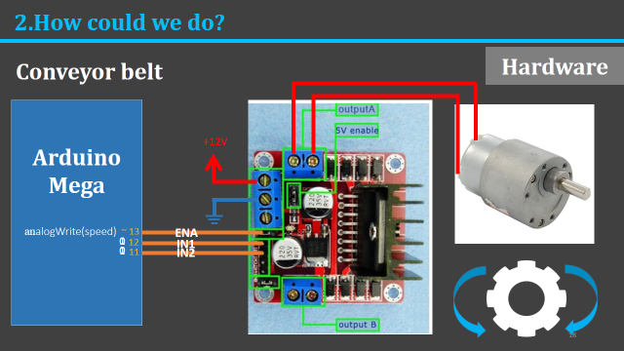

Figure 18: <How> L298 H Dual Bridge and DC Motor

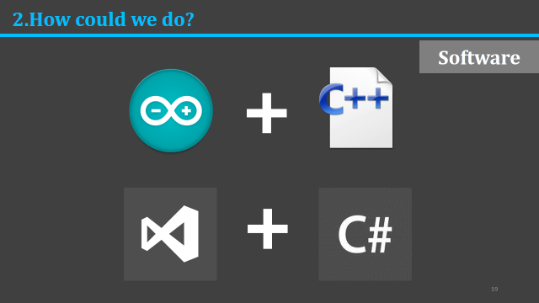

Figure 19: <How> Language Programming

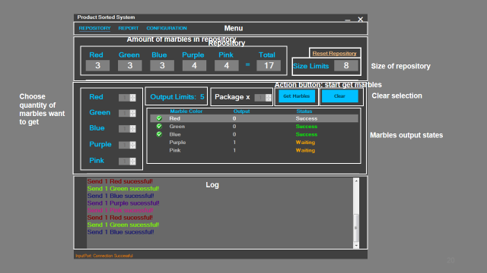

Figure 20: <How> Marble Management Interface

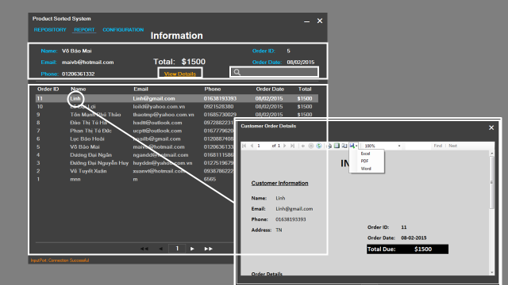

Figure 21: <How> Report Order Details Interface

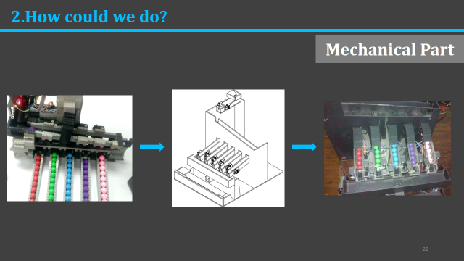

Figure 22: <How> Mechanical Design

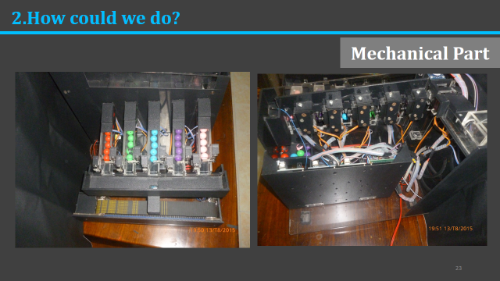

Figure 23: <How> Mechanical Detail

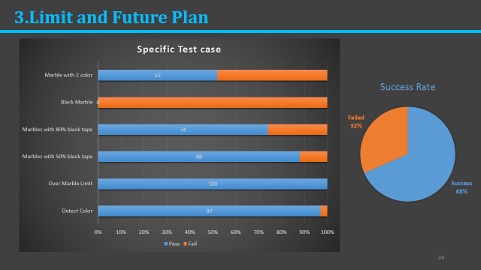

Figure 24: <Limit and Plan> Testing Report

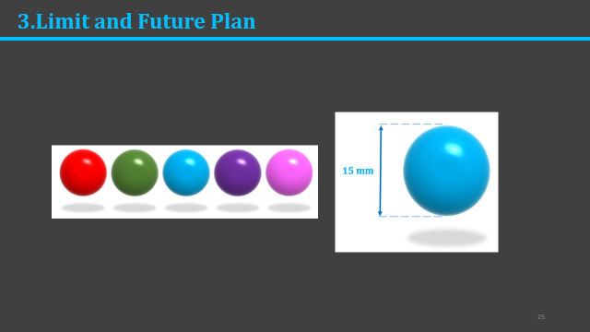

Figure 25: <Limit and Plan> Marbles Limit

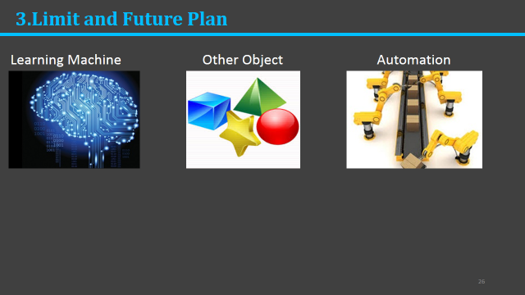

Figure 26: <Limit and Plan> Improvement Plan



Figure 27: Demo Machine



Figure 28: Question and Answer

